IBM Applied Data Science

Coursera Capstone Project

**Opening a new Shopping mall in Bengaluru**

By – utkal bharti

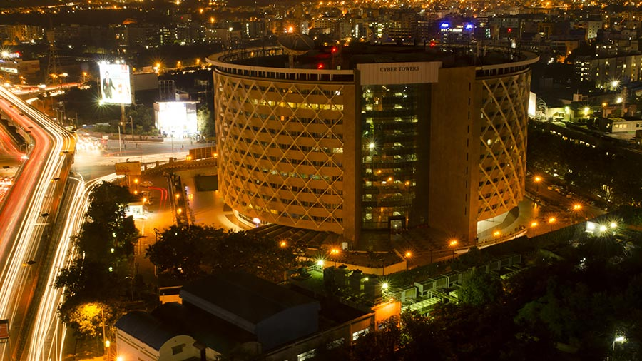

Introduction**:**

The concept of shopping mall came into existence when people started demanding all products at one place. A shoppingmall is a modern, chiefly North American, term for a form of shoppingprecinct or shopping center in which one or more buildings form a complex of shops with interconnecting walkways, usually indoors.  It is a place they could go and hangout with their friends and be relatively safe. Shopping malls are like a one-stop destination for all types of shoppers. For many shoppers visiting shopping mall is a great way to relax and enjoy themselves during weekends and holidays. Property dealers are also taking advantage of this trend to build more shopping malls to cater the demand. There are many shopping malls in the city Bengaluru and many more are being built. Now a days shopping mall is a great source of income as well as for generating employment. Opening a new shopping mall requires serious consideration. Particularly the location of shopping mall is one of the most important decision that will determine whether the mall will be successful or a failure

Business Problem:

The objective of this capstone project is to analyse and select the best locations in the city Bengaluru, India to open a new shopping mall. If a property dealer wants to open a new shopping mall in Bengaluru , where would we recommend them to build, this answer will be given by this project. We will be using Data science methodology and machine learning techniques like clustering in this project.

Target Audience:

This project is useful for the investors and makers who want to open a new shopping mall in Bengaluru city, capital of state Karnataka, India. This project gives them the insights regarding where they should open a new shopping mall. With the help of this project they will find the proper location for the opening of shopping mall that plays a very vital role in the success and a failure of shopping mall.

Data Set

We need following data set to solve the problem:

* List of neighborhoods in Bengaluru, the capital of state Karnataka , India which is situated at south east of Asia.
* Latitude and longitude coordinates of neighborhoods of the city Bengaluru.
* Coordinates are required to plot the map of the city Bengaluru and also to get the venues.
* Venue data, particularly data related to shopping malls. We will use this data set to perform clustering on the neighborhoods.

Source of data and methods to extracts them:

This Wikipedia page (”<https://en.wikipedia.org/wiki/Category:Neighbourhoods_in_Bangalore>”) contains the list of neighborhoods in Bengaluru,with a total of 129 neighborhood .We will use web scrapping techniques to extracts the data from the Wikipedia page with the help of python request and beautiful soup packages. Then we will use Python geocoder package and with the help of this package we get the geographical coordinates of the neighborhoods of Bengaluru and also with the help of this package we will get the latitude and longitude of neighborhoods.

After that we will use Foursquare API to get the venue data for those neighborhoods. Foursquare has one of the largest database of 105+ million places and is used by over 125,000 developers. Foursquare API will provide many categories of the venue data , we are particularly interested in the shopping mall category in order to help us to solve the business problem . This is a project that will make use of many data science skills , from web scrapping(Wikipedia) and map visualization(folium).

Maps:

Bengaluru city maps with its neighborhoods

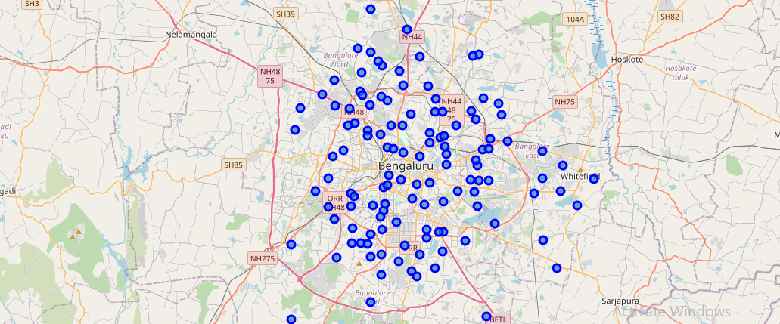

Observation:

Cluster 0:

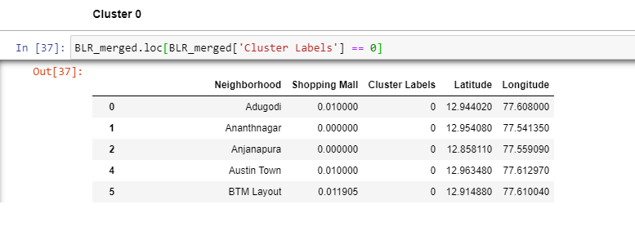

Cluster 1:

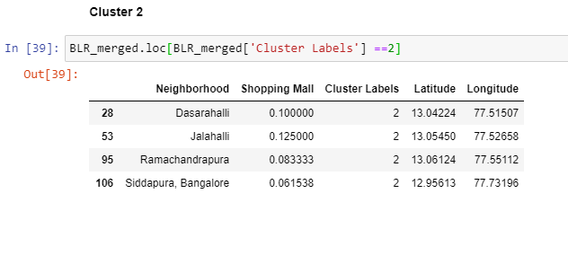

Cluster 2:



Results**:**

We have categorized the neighborhood into three clusters based on the frequency of occurrence of Shopping mall.

* cluster 0: Neighborhood with minimum number of shopping mall
* cluster 1: Neighborhood with maximum number of shopping mall
* cluster 2: Neighborhood with moderate number of shopping mall

The results of the cluster are visualized in the below map. Cluster 0 in red , Cluster 1 in purple and Cluster 2 in mint green colour.

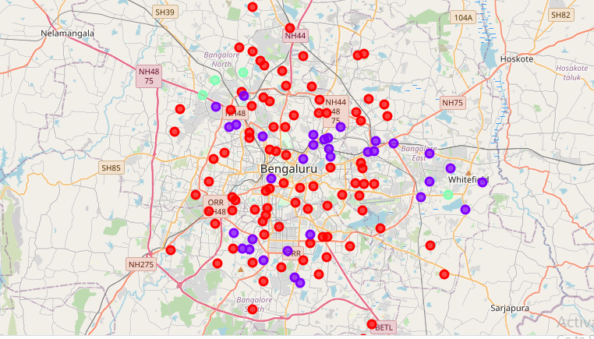

Discussion:

By observing the maps in the result section we can say that most of the shopping malls are concentrated in the outer areas of main city with the highest number in cluster 2 and moderate in cluster 1. On the other hand cluster 1 has low to no shopping mall in the neighborhoods. This represent a great opportunity for the investors and make to open new shopping mall there as there is very little to no competition from existing malls. Meanwhile in cluster 2 shopping mall are likely to suffer from intense competition from existing malls. Therefor this project recommends investors and makers to open new shopping mall in neighborhood in the cluster 0 with low to no competition. Investors should avoid investing capital in cluster 1 for making shopping malls.

Limitation and suggestions for future research:

In this project we consider only one factor, i.e. frequency of occurrence of shopping malls, there are many other factors such as population, area density, income of residents that could influence the location of decision of a new shopping mall. This project made use of free Sandbox Tier Account for Foursquare API that came with limitations like number of API calls and results returned. For future research one could make use of paid account which does not come with such limitations.

Conclusion:

Most of the shopping malls are concentrated in the outer area of Bengaluru city, with the highest number in cluster 2 and moderate number in cluster 1. On the other hand, cluster 0 has very low number to totally no shopping mall in the neighborhoods. This represents a great opportunity and high potential areas to open new shopping malls as there is very little to no competition from existing malls. Meanwhile, shopping malls in cluster 2 are likely suffering from intense competition due to oversupply and high concentration of shopping malls. From another perspective, this also shows that the oversupply of shopping malls mostly happened in the central area of the city, with the suburb area still have very few shopping malls.. Property developers with unique selling propositions to stand out from the competition can also open new shopping malls in neighborhoods in cluster 2 & 3 with moderate competition.

References:

Category: Neighborhoods of Bengaluru city from Wikipedia

<https://en.wikipedia.org/wiki/Category:Neighbourhoods_in_Bangalore>

Foraquare Developers Documentation.

<https://developer.foursquare.com/docs/>